

***School of Mechanical & Manufacturing Engineering (SMME),***

***National University of Science and Technology (NUST),***

***Sector H-12, Islamabad***

Program: BE-Aerospace Section: AE-01

Session: Fall 2023 Semester: 1st

Course Title: Fundamentals of Programming (CS-109)

Assignment

***“_________________________”***

***Name: Ali Tawasal Awan***

***CMS:*** 455925

1. Write a C++ program, take two strings as input from user and check if both strings

are equal or not. If they are equal make them unequal by rotating string. e.g., Hello

is turned into olleH etc.

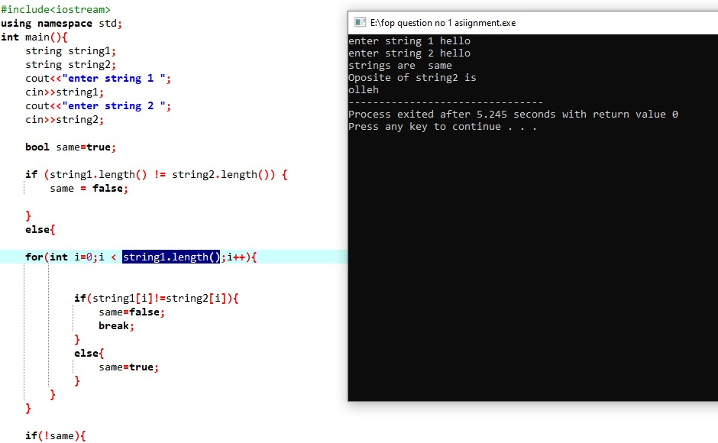

Code for equalication of string:

Question no 1

Complete programme

#include<iostream>

using namespace std;

int main(){

string string1;

string string2;

cout<<"enter string 1 ";

cin>>string1;

cout<<"enter string 2 ";

cin>>string2;

bool same=true;

if (string1.length() != string2.length()) {

same = false;

}

else{

for(int i=0;i < string1.length();i++){

if(string1[i]!=string2[i]){

same=false;

break;

}

else{

same=true;

}

}

}

if(!same){

cout<<"strings are not same"<<endl;

}

else{

cout<<"strings are same"<<endl;

cout<<"Oposite of string2 is "<<endl;

for(int j=4;j>=0;j--){

cout<<string2[j];

}

}

}

2. Write a C++program for a string which may contain lowercase and uppercase

characters. The task is to remove all duplicate characters from the string and find

the resultant string.

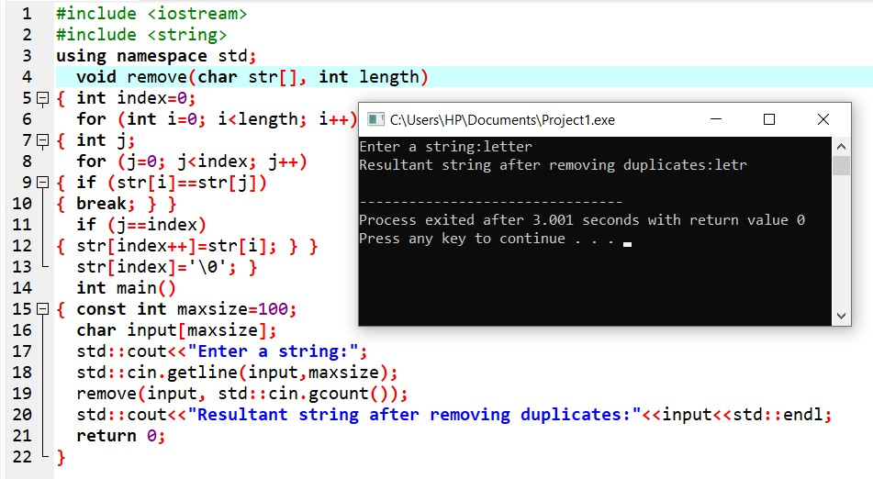

Question no 2

#include<iostream>

using namespace std;

int main(){

string string1;

cout<<"enter string ";

cin>>string1;

for(int i=0;i<string1.length();i++){

bool same=true;

for(int j=i+1;j<string1.length();j++){

if(string1[i]==string1[j]){

same=false;

break;

}

}

if(same){

cout<<string1[i];

}}}

3. Suppose an integer array a[5] = {1,2,3,4,5}. Add more elements to it and display

them in C++.

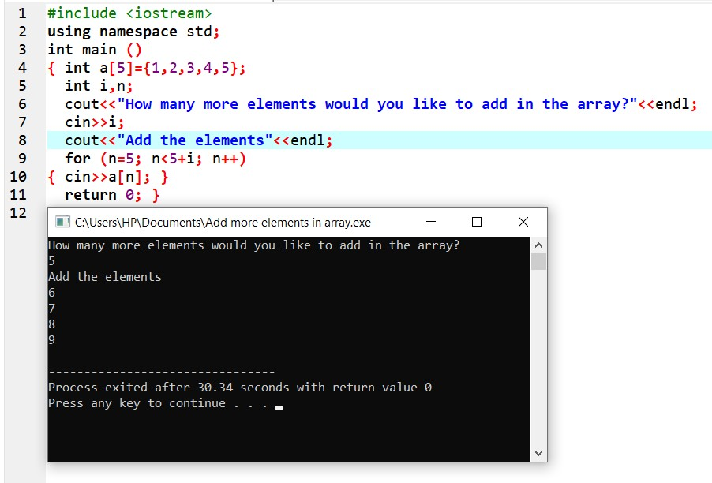

**Question no 3**

**#include<iostream>**

**using namespace std;**

**int main(){**

**int n;**

**cout<<"Enter number of elements you want to enter in Array: ";**

**cin>>n;**

**int array[5+n]={1,2,3,4,5};**

**cout<<"Enter additional elements: ";**

**for(int i=5;i<n+5;i++){**

**cin>>array[i];**

**}**

**for(int k=0;k<5+n;k++){**

**cout<<array[k];**

**}**

**}**

4. Write a C++ program that uses a while loop to find the largest prime number less

than a given positive integer N. Your program should take the value of N as input

from the user and then find the largest prime number less than or equal to N. You

are not allowed to use any library or pre-existing functions to check for prime

numbers.

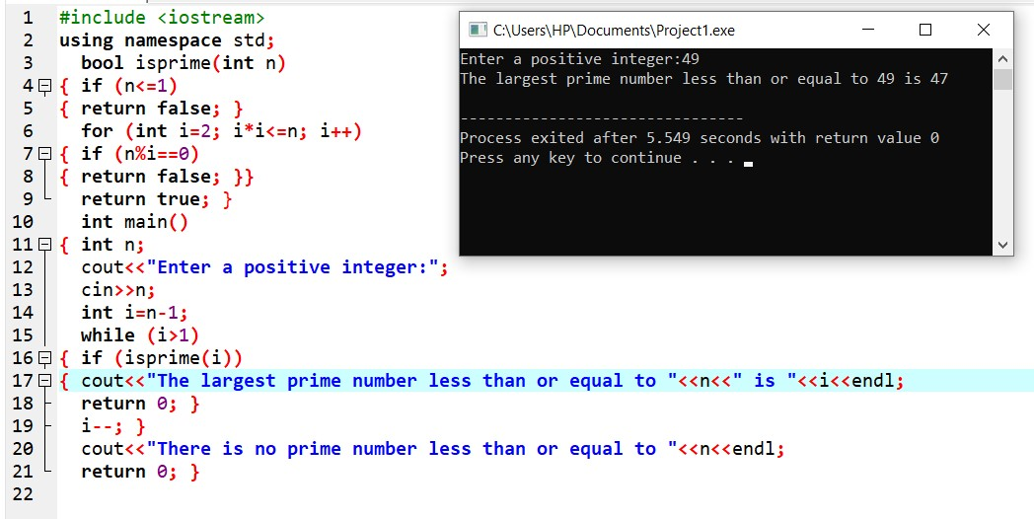

Question no 4

#include<iostream>

using namespace std;

int main(){

int max=0;

int i=6;

int n;

cout<<"Enter number upto which you want to find the prime number: ";

cin>>n;

cout<<"Prime numbers upto "<<n<<" are"<<endl;

while(i<=n){

if(i%2!=0 && i%3!=0 && i%5!=0){

cout<<i<<endl;

if(max<i){max=i;

}

i++;

}

i++;

}

cout<<"Max no is "<<max;

}

5. Implement Bubble Sort on an array of 6 integers.

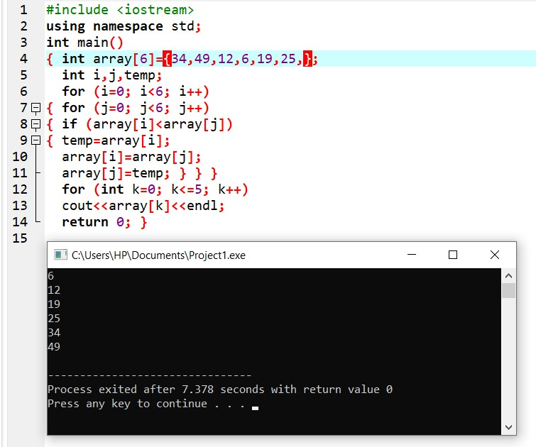

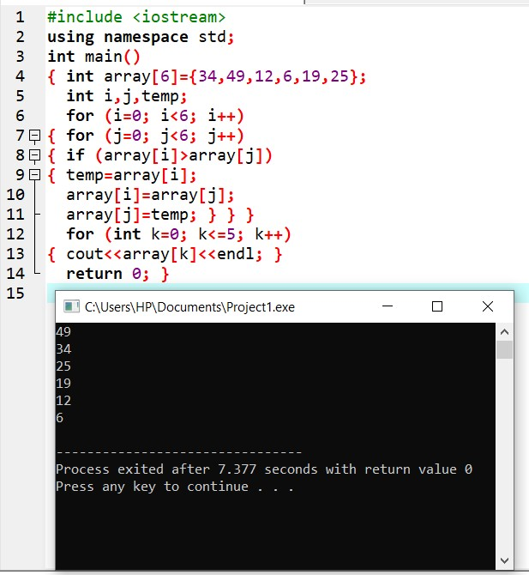

Question no 5

#include<iostream>

using namespace std;

int main(){

int array[6]={3,4,6,1,2,5};

for(int j=0;j<6;j++){

for(int i=0;i<6;i++){

if(array[i]>array[i+1]){

int temp=array[i];

array[i]=array[i+1];

array[i+1]=temp;

}

}

}

cout<<"Ascending order "<<endl;

for (int k=0;k<6;k++){

cout<<array[k];

}

cout<<endl;

for(int j=0;j<6;j++){

for(int i=0;i<5;i++){

if(array[i]<array[i+1]){

int temp=array[i];

array[i]=array[i+1];

array[i+1]=temp;

}

}

}

cout<<"Descending order "<<endl;

for (int z=0;z<6;z++){

cout<<array[z];

}

}

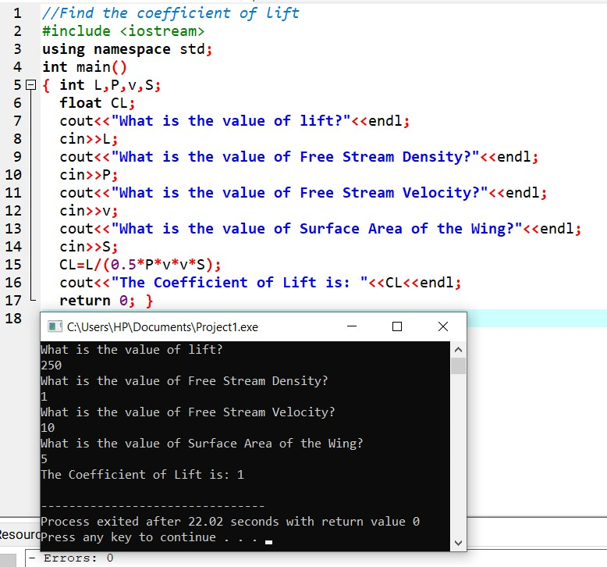6. Solve any aerospace/real life Problem using C++ Programming

//Find the coefficient of lift

#include <iostream>

using namespace std;

int main()

{ int L,P,v,S;

float CL;

cout<<"What is the value of lift?"<<endl;

cin>>L;

cout<<"What is the value of Free Stream Density?"<<endl;

cin>>P;

cout<<"What is the value of Free Stream Velocity?"<<endl;

cin>>v;

cout<<"What is the value of Surface Area of the Wing?"<<endl;

cin>>S;

CL=L/(0.5*P*v*v*S);

cout<<"The Coefficient of Lift is: "<<CL<<endl;

return 0; }